**INTERNATIONAL UNIVERSITY**

**VIETNAM NATIONAL UNIVERSITY – HO CHI MINH CITY**

**School of Computer Science and Engineering**

**-----***-----**

**PROJECT REPORT**

**MONOPOLY UNIVERSE**

**OBJECT-ORIENTED PROGRAMMING (IT069IU)**

**Course by Dr. Tran Thanh Tung and MSc. Pham Quoc Son Lam**

**Student’s ID**

ITITUN21003

ITDSIU20031

ITDSIU21055

ITDSIU21057

ITDSIU20090

**FLOP TEAM MEMBERS:**

Tran Nguyen Trung Quan

Nguyen Quang Dieu

Hoang Tuan Kiet

Nguyen Hai Ngoc

Nguyen Hoang Anh Tu

**TABLE OF CONTENTS**

**LIST OF FIGURES** 2

**CONTRIBUTION TABLE** 3

**ABSTRACT** 4

**CHAPTER 1: INTRODUCTION** 5

**1.** **Objectives** 5

**2.** **The tools used** 5

**CHAPTER 2: METHODOLOGY** 7

**1.** **Rules** 7

**2.** **Design** 8

**3.** **UML Diagram** 14

**CHAPTER 3: DEMO – RESULT** 20

**CHAPTER 4: CONCLUSION AND FUTURE WORKS** 23

**1.** **Conclusion** 23

**2.** **Future works** 23

**REFERENCES** 24

# **LIST OF FIGURES**

Figure 1. Monopoly Universe banner 5

Figure 2. Microsoft Teams file structure 6

Figure 3. Notion workspace 6

Figure 4. GitHub statistics 6

Figure 5. In-game house rules cover 8

Figure 6. Example of planet title deed 9

Figure 7. Chance and Fortune cards 9

Figure 8. Center of board game 10

Figure 9. Welcome screen 10

Figure 10. Token 10

Figure 11. Dice face 11

Figure 12. Board Interface 11

Figure 13. Project structure 12

Figure 14. UML of the whole project 15

Figure 15. UML of Cards related classes 16

Figure 16. UML of Planet-related classes 17

Figure 17. UML of Player related classes 18

Figure 18. UML of Main game-related classes 19

Figure 19. Menu screen from the game 20

Figure 20. Help screen 21

Figure 21. Initial board game 21

Figure 22. During the gameplay 22

# **CONTRIBUTION TABLE**

|  |  |  |  |
| --- | --- | --- | --- |
| No. | Full Name | Student’s ID | Contribution |
| 1 | Nguyễn Quang Diệu | ITDSIU20031 | 15% |
| 2 | Hoàng Tuấn Kiệt | ITDSIU21055 | 15% |
| 3 | Nguyễn Hải Ngọc | ITDSIU21057 | 15% |
| 4 | Trần Nguyễn Trung Quân | ITITDK21071 | 30% |
| 5 | Nguyễn Hoàng Anh Tú | ITDSIU20090 | 25% |

# **ABSTRACT**

The board game **Monopoly**, which the Hasbro firm produces, was adapted in 1993 from Lizzie Magie's The Landlord's Game (Pilon, 2015). The game involves players moving around the game board while purchasing and trading homes or hotels to enhance their individual properties.

In this undertaking, the FLOP team created the game Monopoly Universe to provide players with a modernized version of Monopoly. The game's theme is recreated based on the idea of the galaxy and outer space. Along with the new idea, the Hasbro fundamental rules are still present, but the game rules have been altered to correspond with the local games played in Vietnam. By presenting details on many planets in the universe and outer space, the game also aids players in expanding their understanding of astronomy. This is the product of the effort to provide players, usually young pupils, with a game that is both entertaining and educational.

Keywords: monopoly, galaxy, universe, education, game, object-oriented programming.

# **CHAPTER 1: INTRODUCTION**

### **Objectives**

The project's goal is to create a fully playable game based on galactic conceptions and the fundamental concept of the first Monopoly game. The game can also demonstrate the four qualities of object-oriented programming (OOP) and the fundamentals of design patterns. To further enhance the game, commitments from others may also be acceptable.

To be short, the project aims to:

* Create a game that is redesigned to entertain and educate players.
* Practicing OOP techniques in the Theory class.
* Go through the process of game management and code refining.
* Evaluate the ability to build more features on top of the basic code.

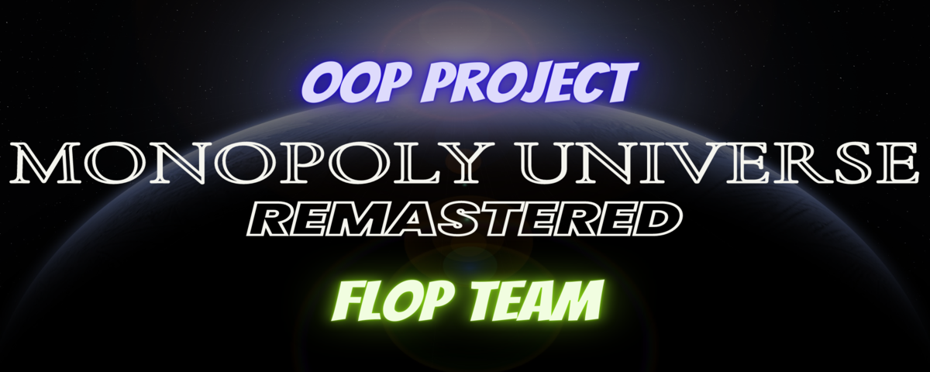

Figure 1. Monopoly Universe banner

### **The tools used**

* IDE for programming and debugging: JetBrains IntelliJ.
* Mean of code version management: GitHub.
* Means of contacting: Notion and Microsoft Teams.

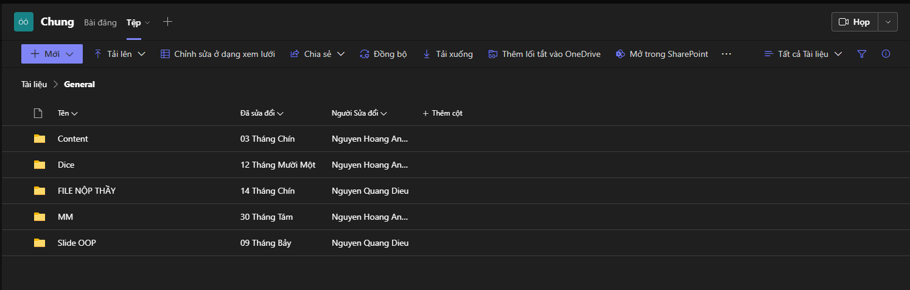

Figure 2. Microsoft Teams file structure

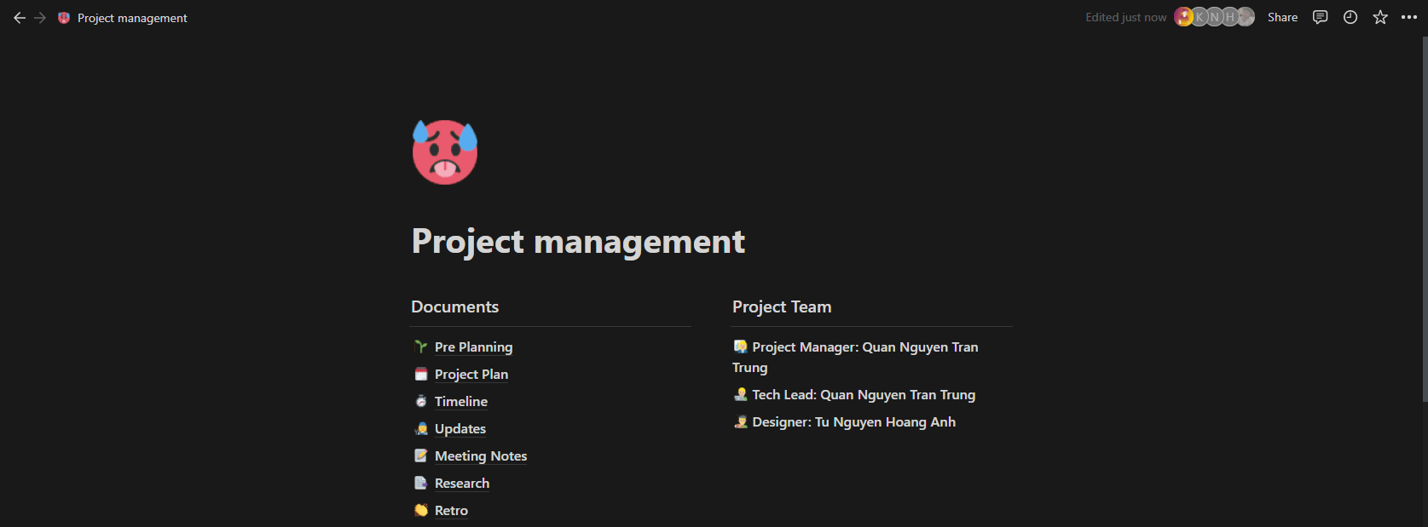

Figure 3. Notion workspace

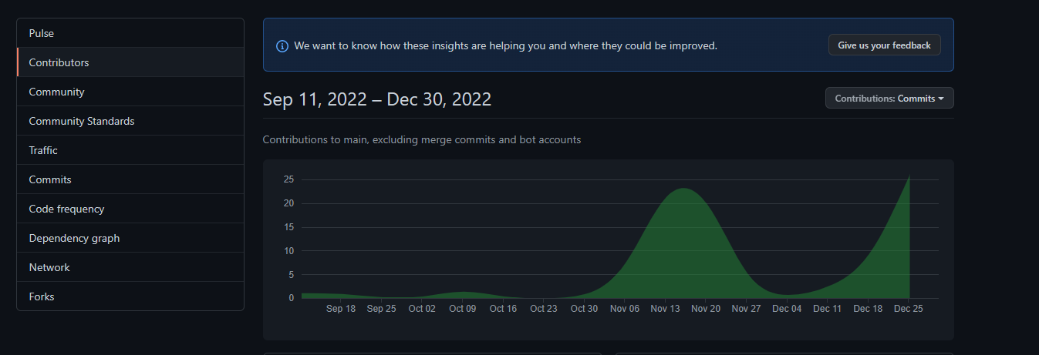

Figure 4. GitHub statistics

# **CHAPTER 2: METHODOLOGY**

### **Rules**

The team tried to adapt from the original game rules (*How to Play Monopoly | Official Rules | UltraBoardGames*, n.d.), which can be found online; here is the summary of the main points:

* **OBJECT** of the game is to become the wealthiest player by buying, renting, and selling property.
* **INITIAL MONEY** all players will start with ₲1,500 and 100 MANA.
* **THE GAMEPLAY** each player turns to roll the dice and move their spacecraft as shown on the dice. Then you can perform other tasks like *build, sell, mortgage* and *rent*, finish turn and pass to others.
* **PASSING STARTING POINT,** you receive ₲200 each time.
* **BUYING PROPERTIES** you must pay the amount shown on the planet or be rejected to buy if the conditions are not met (i.e., not enough money, not available).
* **CHANCE AND FORTUNE CARDS** follow the direction on the card; however, you may keep the "*RESTORING SPACECRAFT CARD*" for yourself.
* **ALPHA JUMP/ LOST CONNECTION** you must pay the amount shown on the board to restore your spacecraft to a normal state.
* **COLLIDING** when you go to the space marked, draw the card, or throw three times double in a row, you will be sent to the International Space Station.
* **COLLIDING RULES** no rents are collected during this state, and you can pay ₲50 to restore your spacecraft at the ISS.
* **RESTORING SPACECRAFT** by throwing a double, paying the ₲50, or using "*RESTORING SPACECRAFT CARD*" to restore.
* **REFUELING** your MANA will restore it to the maximum it can hold.
* **PLANET UPGRADE** must be done evenly on each property in a color group.
* **DOWNGRADE COST** you only receive 50% of the purchase price when downgrading the specified planet.
* **MORTGAGE PLANET** to receive the amount bought and to ***unmortgage***, pay a 10% fee from the original price.
* **DECLARE BANKRUPT** when you cannot pay the fee, your properties will transfer to your lender, but he/she must pay 10% free loans on each planet.

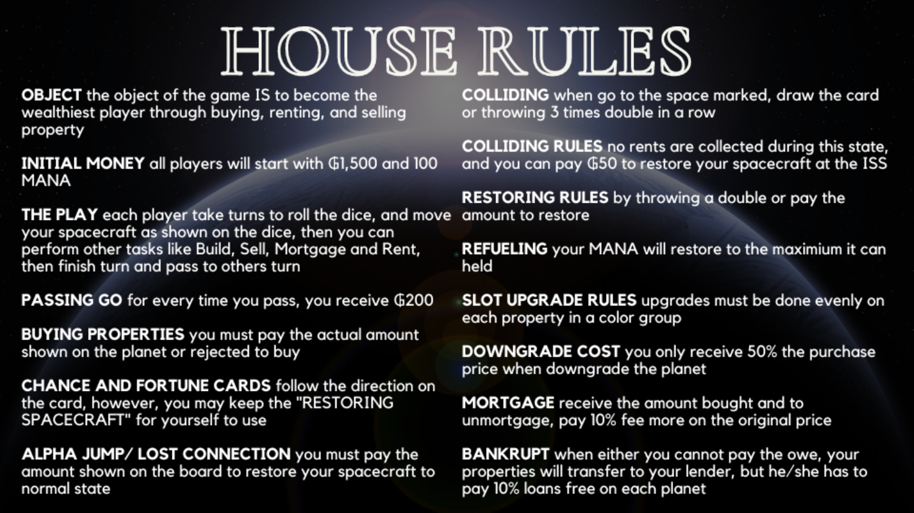

Figure 5. In-game house rules cover

### **Design**

* 1. *UI/UX*

UI/UX has always been our first concern before playing the game, so we must think much of inspiration from others and produce our layout.

With a twist from the Universe theme, we focused on changing three things: the avenue is replaced by a planer, the introduction of the ₲aly and MANA system, and utterly new galaxy-exclusive content. To prepare for a theme redesign, we must go through 3 steps, which are:

1. Research on the information of the planets (*All Resources | Resources*, n.d.; *Exoplanet Catalog | Discovery*, n.d.), including their properties such as distance to Earth, its unique sights, and many more.
2. Create a property theme based on the original ones.
3. Team members' feedback and modifying until we found the best color and design pattern combinations.

In specific, each component we have redesigned includes the following:

* Planet cards

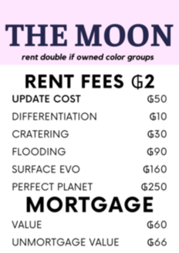

Figure 6. Example of planet title deed

* 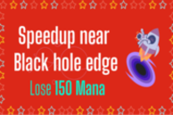Chance and Fortune cards

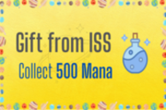

Figure 7. Chance and Fortune cards

* Board of the game



Figure 8. Center of board game

* Game's Welcome screen

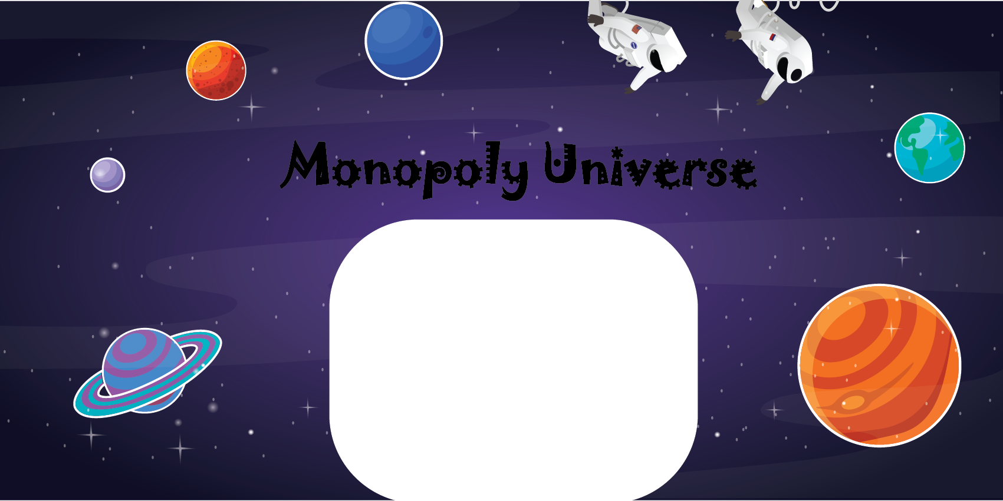

Figure 9. Welcome screen

* Player' token



Figure 10. Token

* Dice



Figure 11. Dice face

Putting them together with some parts taken online:

* Sound
* Buttons

The results look like this:

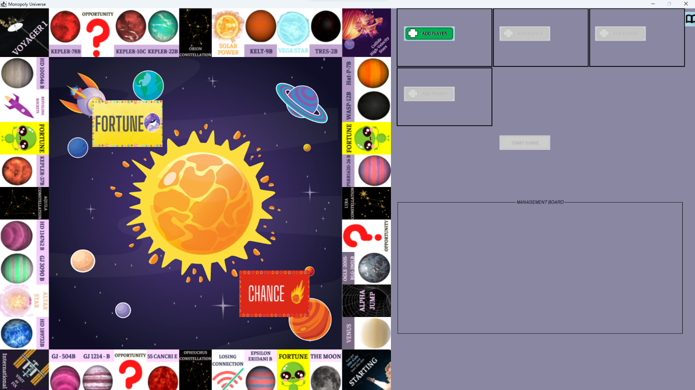

Figure 12. Board Interface

To ensure the game is played as we intended, the client's screen resolution must be 1920x1080. Otherwise, the game will break. In addition, the UX of the game was also our big concern since we have little knowledge about it, but we managed to do it for user actions like:

* Menu and Help screen
* Buying properties
* Paying rent
* Buy/Sell/Mortgage
* Roll the dice
* The ability to show which planet that player owned using color bars

As we have tried our best, some of the game functions are not running smoothly as we expected them to, but we will be doing more research to better provide the UI/UX of this game in the future.

* 1. *Game algorithm*

After a tremendous amount of time of repeating code and debugging, we have the final project structure like the image below

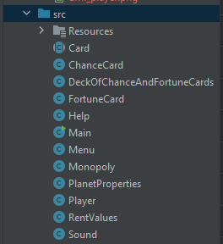

Figure 13. Project structure

We can group our classes into a specific group, such as:

* Card: which contains parent class Card, its subclass ChanceCard, FortuneCard to extends, and DeckOfChanceAndFortuneCards to hold the information of the cards.
* Planet: contains PlanetProperties and RentValues classes to hold the planet's information.
* Player: contains Player and Monopoly classes to keep the player info and initialize the game.
* Main: contains Sound, Main, Help, and Menu to deal with game windows for the user to interact.

To be more specific, we will dig into the group:

* Card
  + We use ArrayList to store the information of each card.
  + A method of dealtCard() uses a Random class to arbitrarily choose a specific card from the deck for the player to deal with.
  + Combine with the getCard() method to give the main game which card it needs to work with.
* Planet
  + To begin, PlanetProperties has many attributes to keep the planet's properties, like the name, color group, owner, mortgage, and availability status, to catch up with the game.
  + Inside RentValue is the ArrayList of entities where we initialize all the planets inside it using the constructor.
* Player
  + The same goes with Planet; inside Player, we also create a list of attributes specified to that Player and have the methods to get their info and control the flow of the game.
  + The Monopoly class is an all-in-one place for the game to create with the help of JFrame libraries and Java Swing components (*Java Swing Tutorial - Javatpoint*, n.d.).
  + It also holds the control logic of the game for features like the upgrade, creation player, and management board.
* Main
  + The primary method of this game initializes a screen that gets an instance of the Menu class
  + Inside the Menu class is where the mouse clicks on each section: Play, Help, and Quit with their respective class to invoke.
    - Play: create a new object of Monopoly and play sound
    - Help: get an instance of the Help object using the **singleton design pattern** (“Singleton Class in Java,” 2017)
    - Quit: exit the Menu object and terminates the program
  + Sound class is added to provide the game with sound for more fun and joy, which has the method of looping(), playing(), and stopping() the music itself.

### **UML Diagram**

To better visualize the structure and algorithms, we included the UML diagrams for the whole project and each group mentioned.

* For the whole project

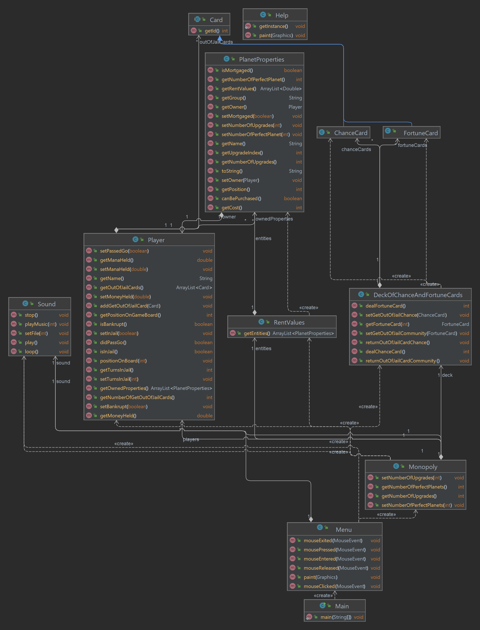

Figure 14. UML of the whole project

* For the scope: Card

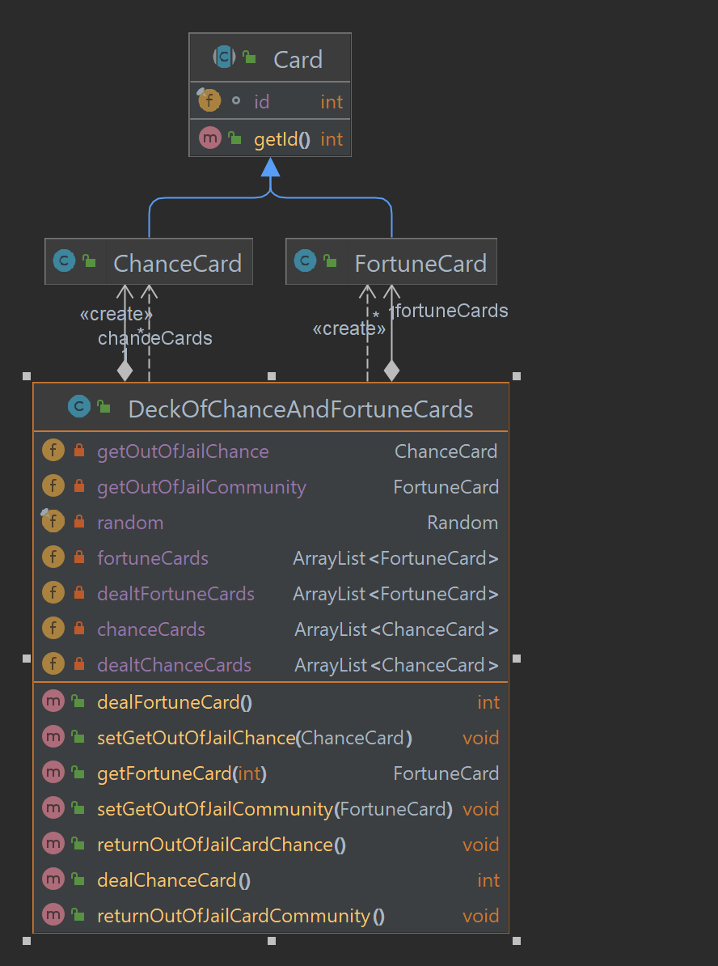

Figure 15. UML of Cards related classes

* For the scope: Planet

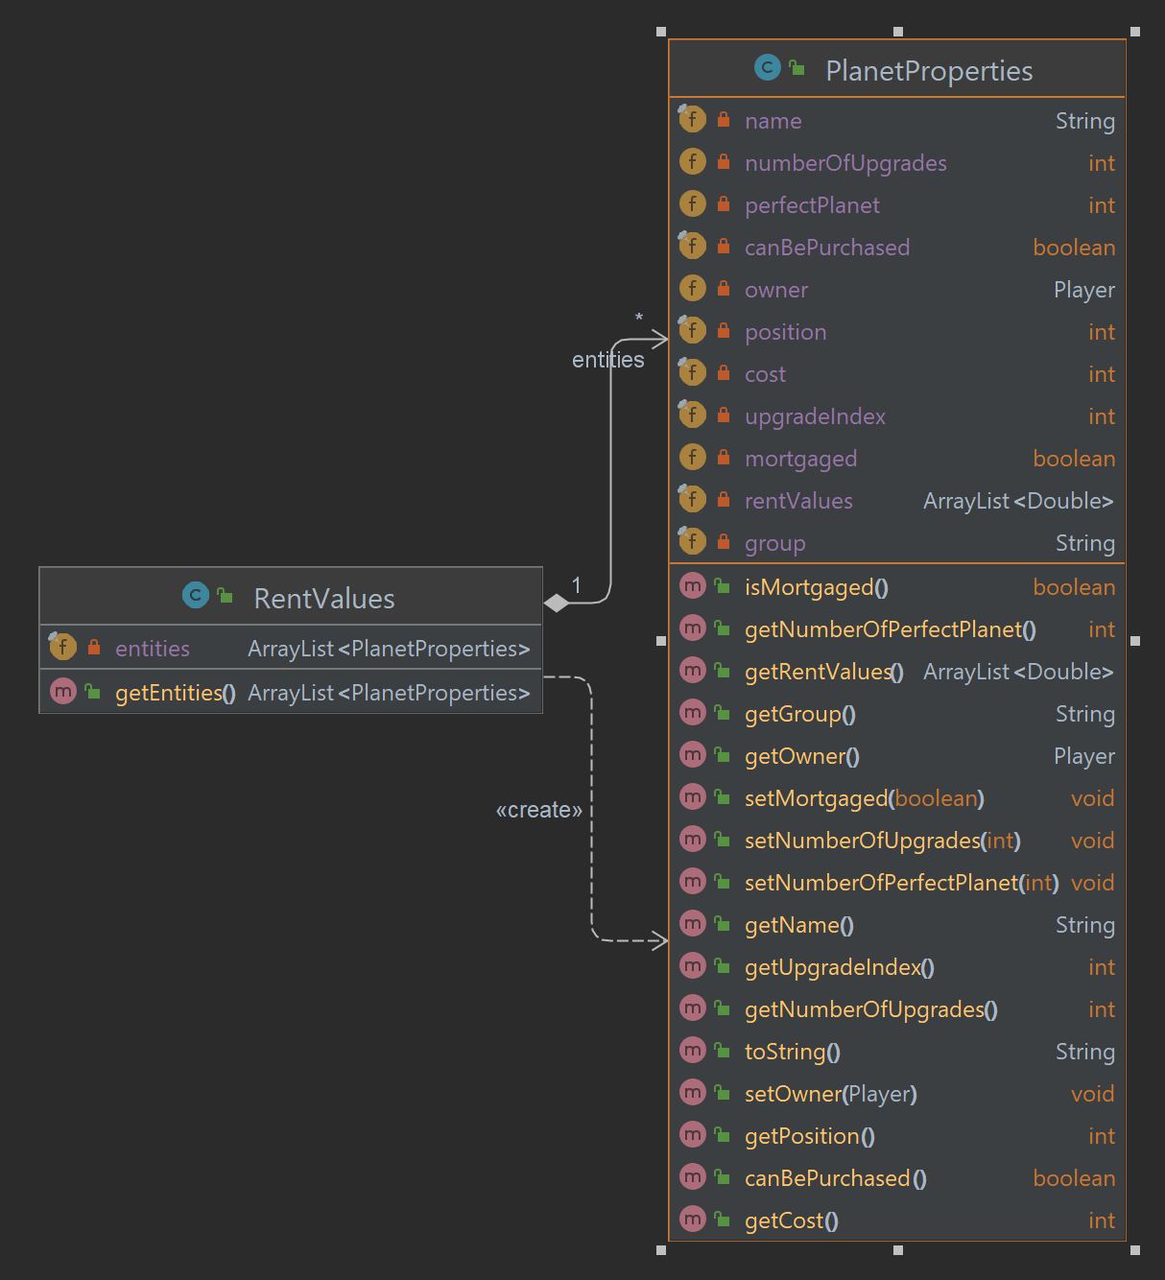

Figure 16. UML of Planet-related classes

* For the scope: Player

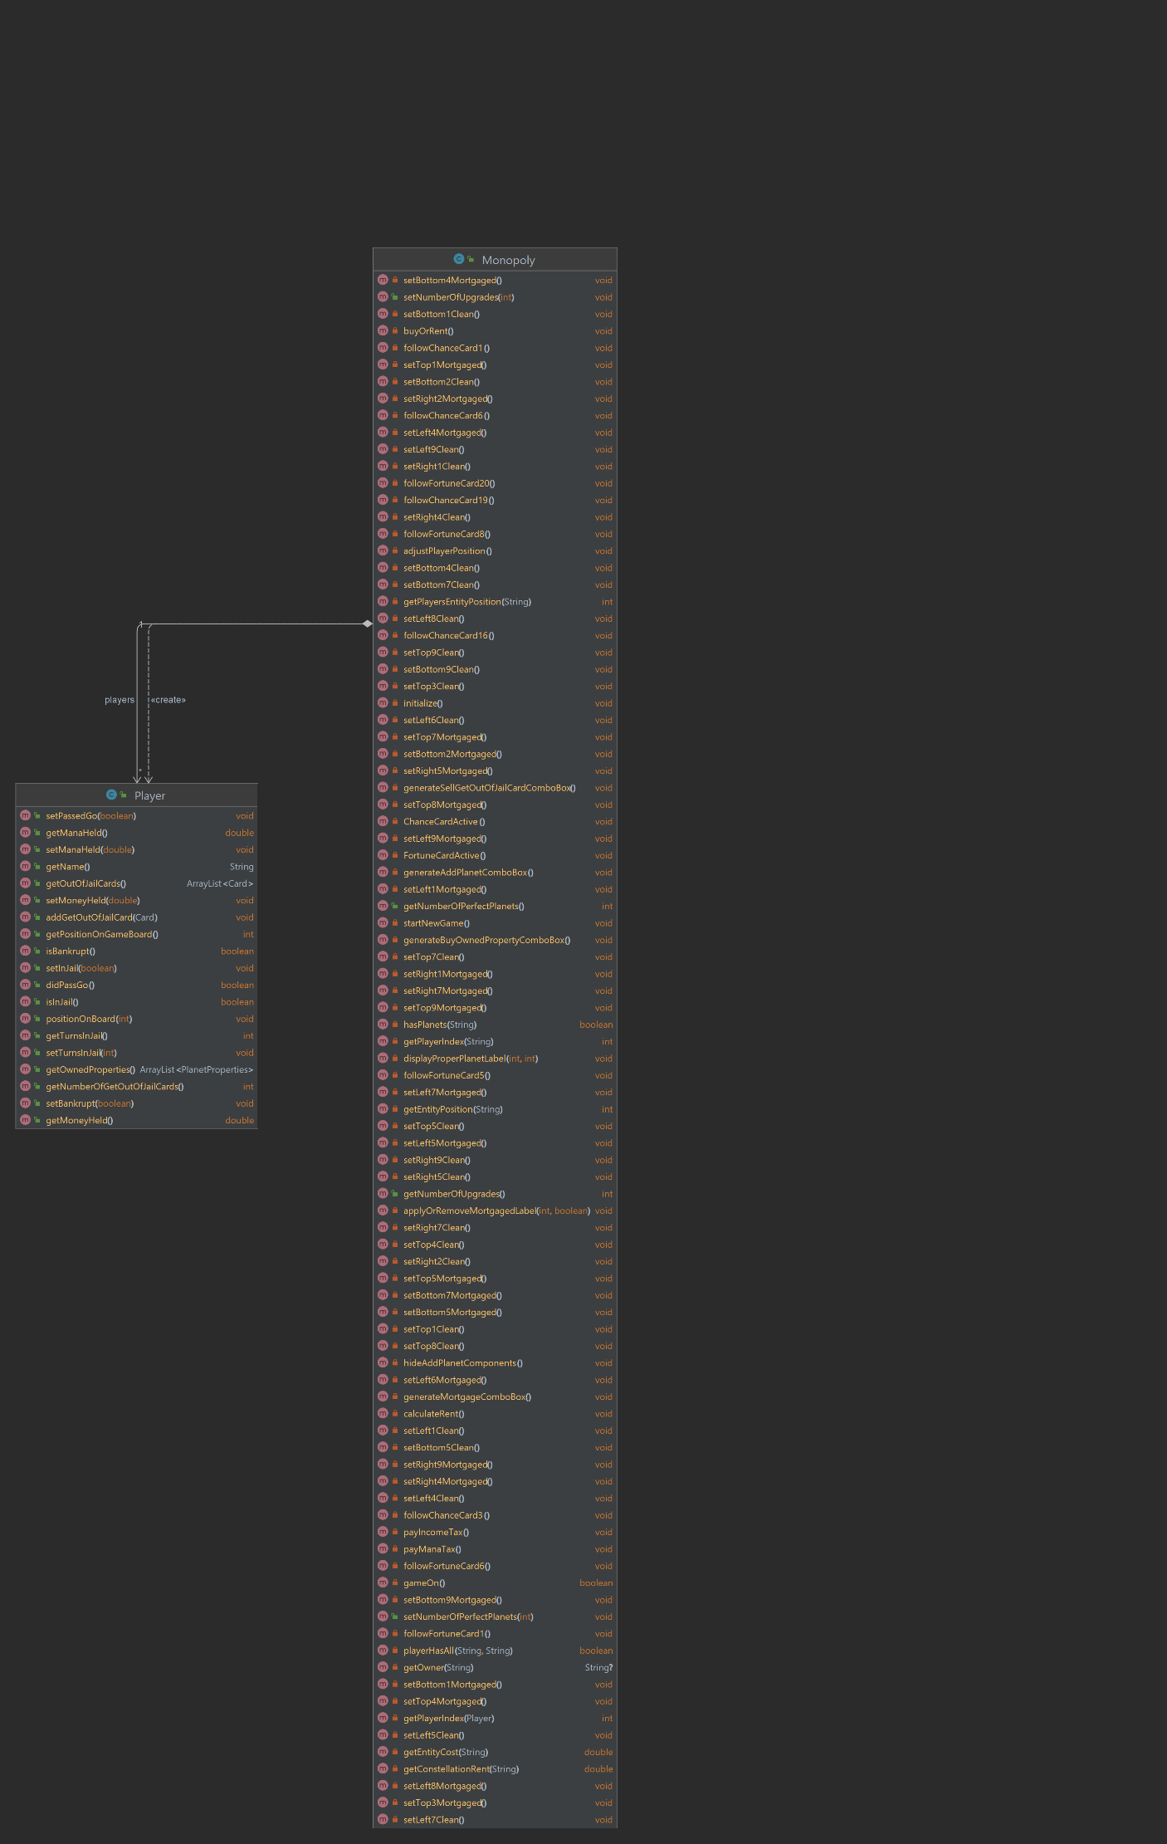

Figure 17. UML of Player related classes

* For the scope: Main

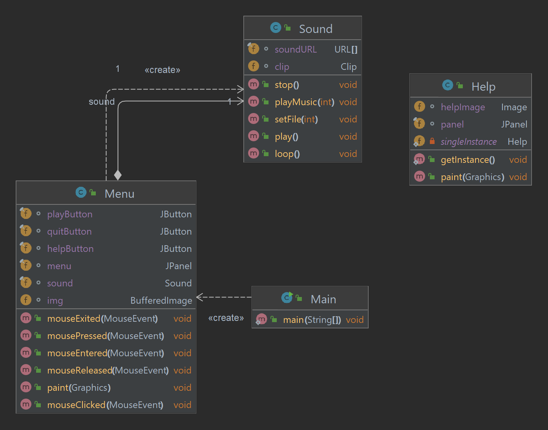

Figure 1818. UML of Main game-related classes

# **CHAPTER 3: DEMO – RESULT**

To test our game on a machine that has installed an IDE and Java Development Kit pulled our git and built the Main to run the game. Below is a sample of the game states that demo the game's current build.

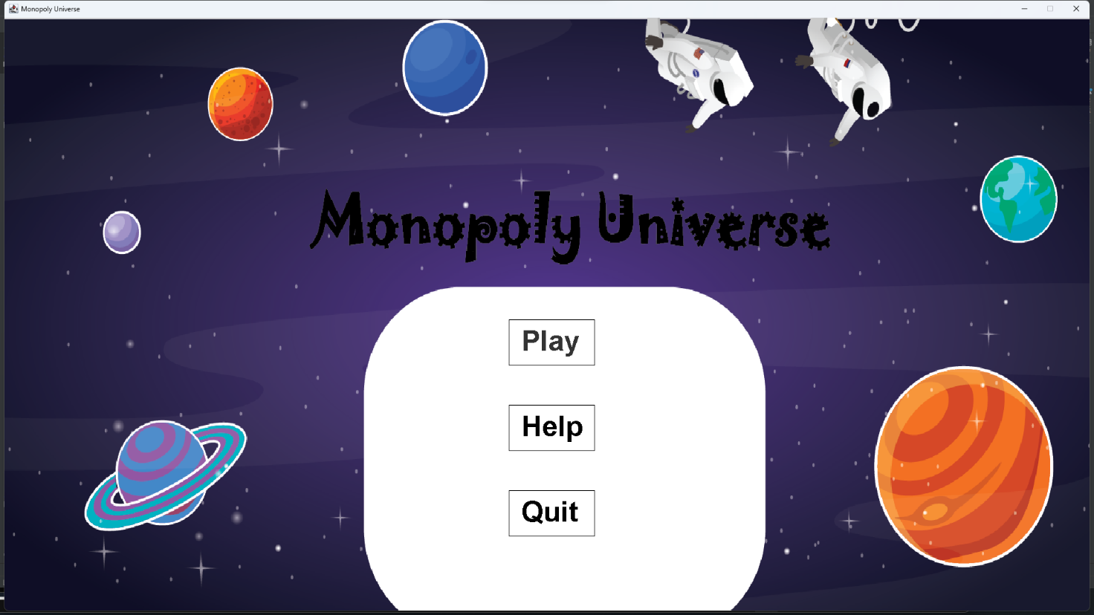

Figure 1919. Menu screen from the game

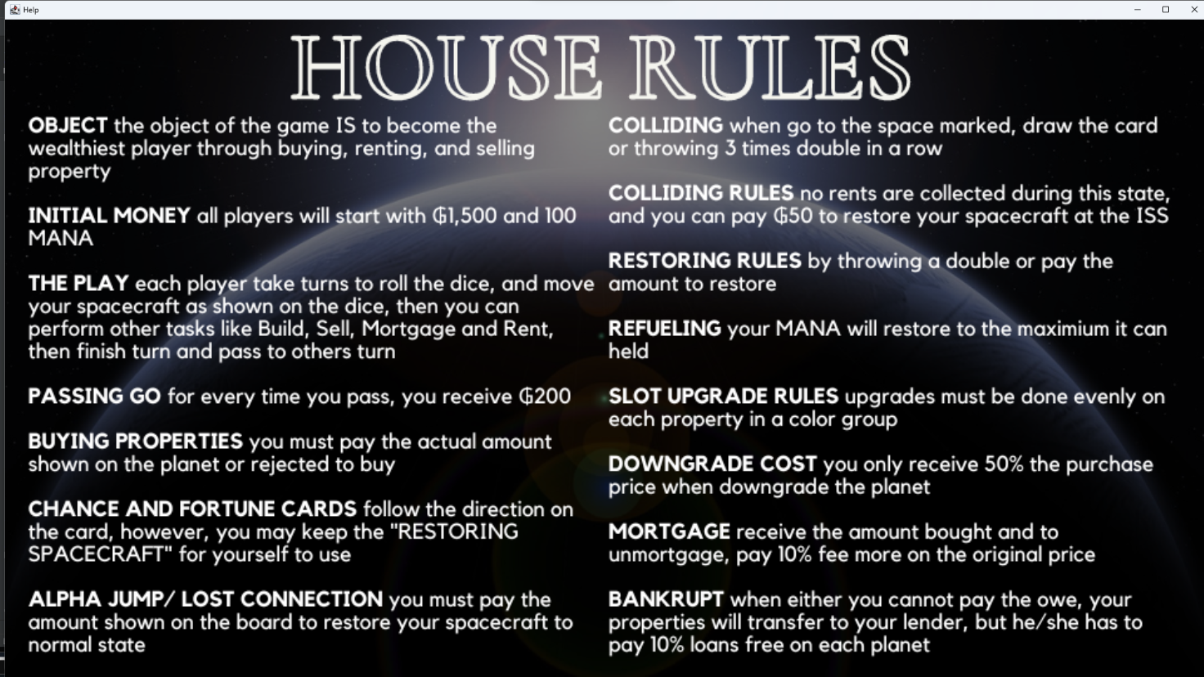

Figure 20. Help screen



Figure 21. Initial board game

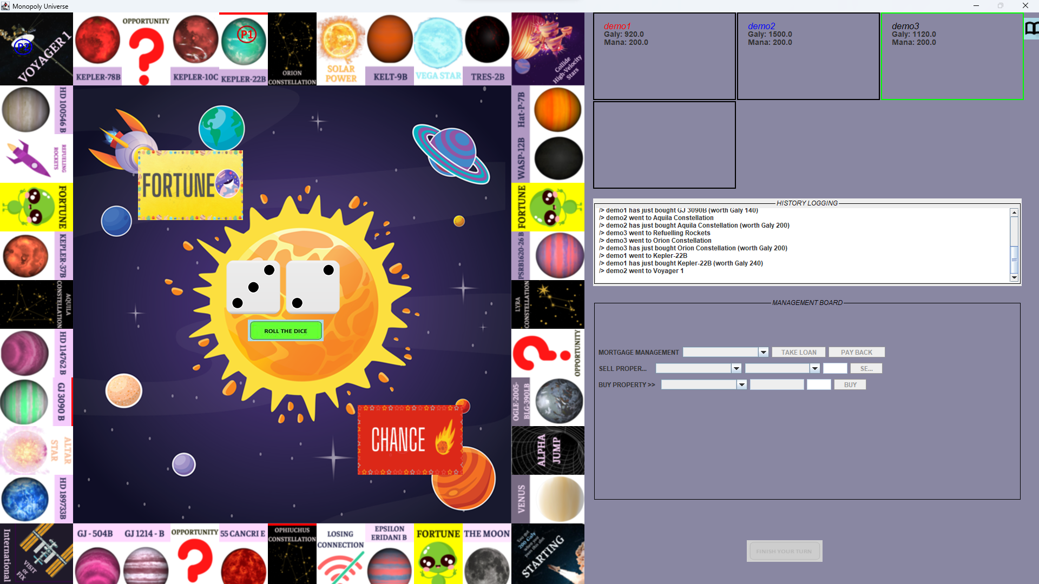

Figure 22. During the gameplay

# **CHAPTER 4: CONCLUSION AND FUTURE WORKS**

### **Conclusion**

The game's development has not yet ended. In the final term, the team has a more robust knowledge of the four features of OOP and the SOLID principle that helps to be fluent in OOP of game development as well as in the programming process after finishing a game with some novel features compared to the original version. The project's classes have discussed the concept of encapsulation. Card class is where inheritance, abstraction, and polymorphism have been used the most frequently. Because of this, Monopoly Universe was strictly developed using the fundamental idea of OOP, and the game code contains all four key OOP features and a design pattern learned from class. The experienced team members will not have a second chance to work on this.

### **Future works**

Unfortunately, the team was hoping to develop a trading feature to control buying and selling among players. In addition, the Mana bar and shop will be included to add extra resources for the players and evaluate the players' management skills. According to that, the Mana bar will be applied to display the current energy level of each player, and the players can use the Mana as a trading unit, like ₲aly. Furthermore, a PvP battle will be played in-game for utilizing the positions in the two-level set with a direct impact on dice rolling will also be applied in future updates. Therefore, any new commitments are highly appreciated.

1. **Acknowledgment**

We want to express our sincerest thanks to our lecturer and the people who have helped us to achieve this project's goals:

* Dr. Tran Thanh Tung
* MSc. Pham Quoc Son Lam
* Original code from pawelpaszki (Paszki, 2015/2021)
* The sites Geeksforgeeks, Javapoints, and so on
* The README.md template from othneildrew (Drew, 2018/2022)

# **REFERENCES**

*All Resources | Resources*. (n.d.). NASA Solar System Exploration. Retrieved December 31, 2022, from https://solarsystem.nasa.gov/resources/all?order=pub_date+desc&per_page=50&page=0&search=&condition_1=1%3Ais_in_resource_list&fs=&fc=&ft=&dp=&category=

Drew, O. (2022). *Othneildrew/Best-README-Template*. https://github.com/othneildrew/Best-README-Template (Original work published 2018)

*Exoplanet Catalog | Discovery*. (n.d.). Exoplanet Exploration: Planets Beyond Our Solar System. Retrieved December 31, 2022, from https://exoplanets.nasa.gov/discovery/exoplanet-catalog

*How to play Monopoly | Official Rules | UltraBoardGames*. (n.d.). Retrieved December 31, 2022, from https://www.ultraboardgames.com/monopoly/game-rules.php

*Java Swing Tutorial—Javatpoint*. (n.d.). Retrieved December 31, 2022, from https://www.javatpoint.com/java-swing

Paszki, P. (2021). *Pawelpaszki/monopoly* [Java]. https://github.com/pawelpaszki/monopoly (Original work published 2015)

Pilon, M. (2015, April 11). The secret history of Monopoly: The capitalist board game’s leftwing origins. *The Guardian*. https://www.theguardian.com/lifeandstyle/2015/apr/11/secret-history-monopoly-capitalist-game-leftwing-origins

Singleton Class in Java. (2017, April 5). *GeeksforGeeks*. https://www.geeksforgeeks.org/singleton-class-java/